CS 419 Compiler
Project Form

Project Idea: project #1 Language
Team Members NO#: 7
ID | Name | Level& Department | Section(Dayfrom-to) | Role (Lead/Member) | Grade
201900997 | يوسف مصطفى صابر | Three |  | Lead
201900818 | مصطفى سيد مصطفى سيد | Three |  | Member
201900563 | فاطمه رضا عبدالمنعم عبد العزيز | Three |  | Member
201900203 | ايمان اشرف احمد عبدالعزيز | Three |  | Member
201900159 | آلاء إبراهيم عبدالعزيز محمد | Three |  | Member
201900329 | سارة ابراهيم صلاح الدين احمد | Three |  | Member
201900930 | هبة محمد عبد الفتاح حسن الخطيب | Three |  | Member

Regular Expression, Finite automata and Conversion from RegX to NFA, NFA to DFA
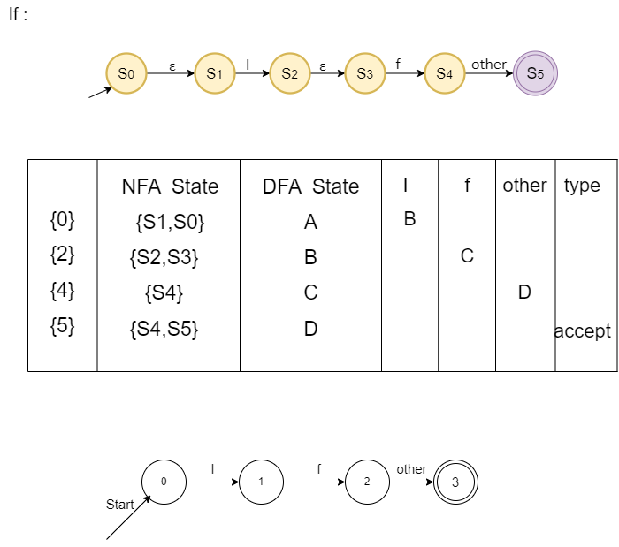
R = If

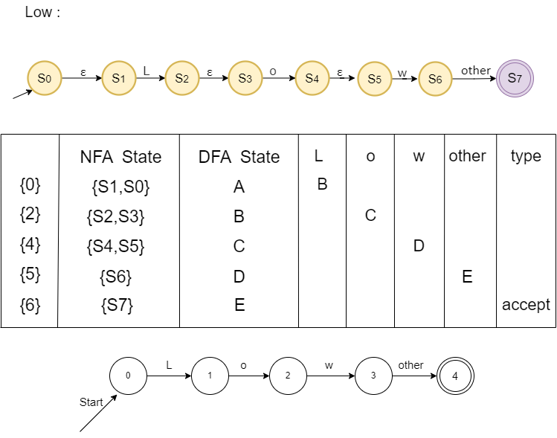
R = Low

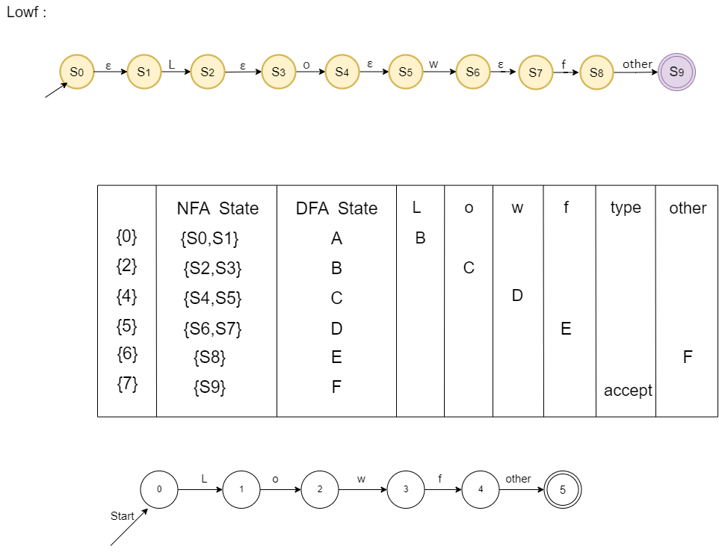
R = Lowf

R = Chain
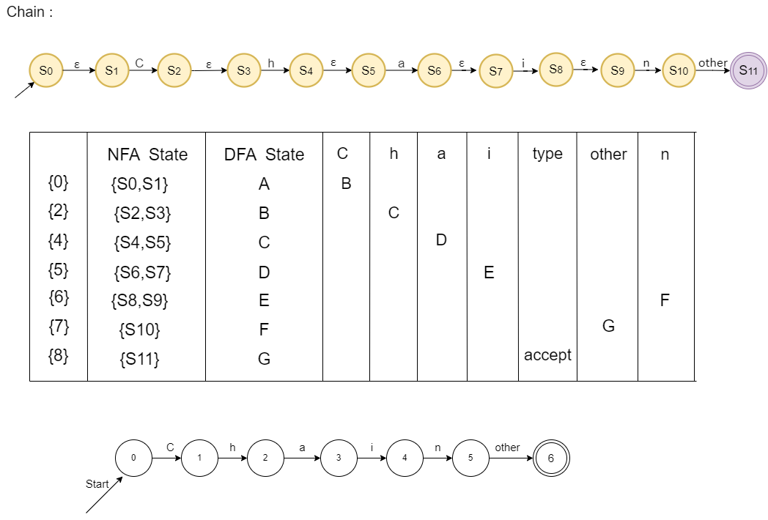

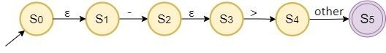
R = (->)

 | NFA STATE | DFA STATE | - |  | > | Other | type
{S0} | {S0 , S1} | A | B
{S2} | {S2 , S3} | B |  | C
{S4} | {S4} | D |  |  |  | E
{S5} | {S5} | E |  |  |  |  | ACCEPTED

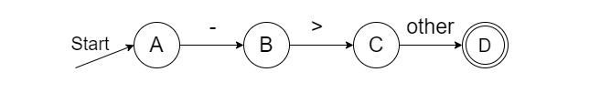
R = && | || | ~

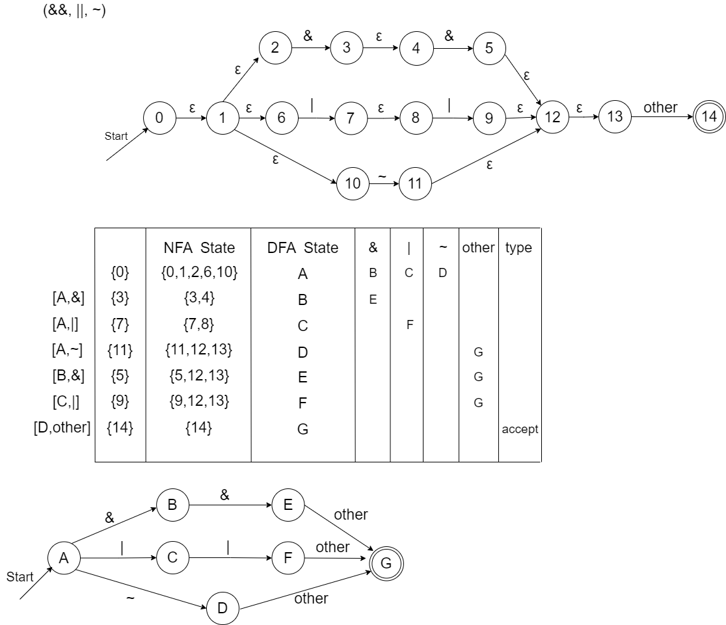

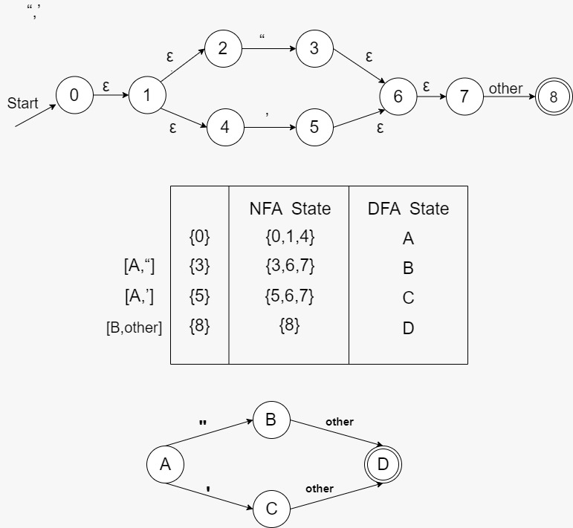
R = (“ | ,)

 | NFA State | DFA State | " | ‘ | other | type
{0} | {0 ,1 ,2, 4} | A | B | C
{3} | {3 , 6, 7 } | B |  |  | D | Accepted
{5} | {5 , 6 , 7 } | C |  |  | D | Accepted
{8} | {8} | D |  |  |  | Accepted

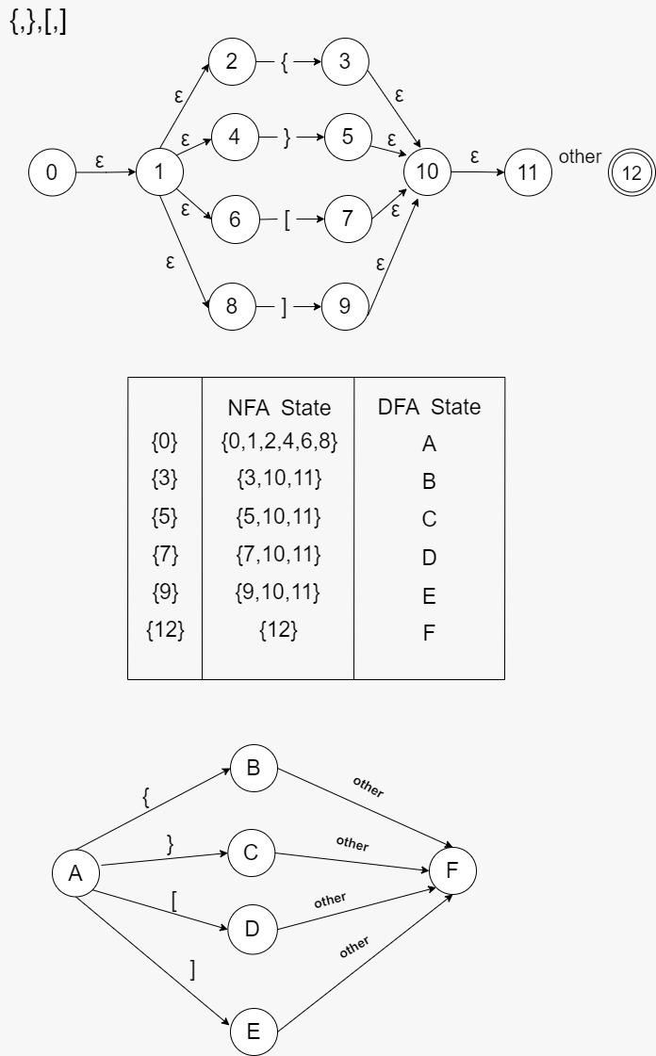
R = { | } | [ | ]

 | NFA State | DFA State | { | } | [ | ] | other | Type
{0} | {0,1,2,4,6, 8 } | A | B | C | D | E
{3} | {3 , 10, 11 } | B |  |  |  |  | F | Accepted
{5} | {5 , 10 , 11 } | C |  |  |  |  | F | Accepted
{7} | {7 , 10 , 11} | D |  |  |  |  | F | Accepted
{9} | { 9 , 10 , 11 } | E |  |  |  |  | F | Accepted
{12} | {12} | F |  |  |  |  |  | Accepted

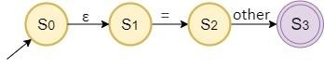
R = ( = )

 | NFA STATE | DFA STATE | = | Other | type
{S0} | {S0 , S1} | A | B
{S2} | {S2 } | B |  | C
{S3} | {S3} | C |  |  | ACCEPTED

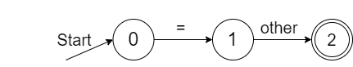

R = Include

 | NFA STATE | DFA STATE | I | N | C | L | U | D | E | Other | type
{S0} | {S0 , S1} | A | B
{S2} | {S2 , S3} | B |  | C
{S4} | {S4 , S5} | C |  |  | D
{S6} | {S6 , S7} | D |  |  |  | E
{S8} | {S8,S9} | E |  |  |  |  | F
{S10} | {S10 , S11} | F |  |  |  |  |  | G
{S12) | {S12,S13) | G |  |  |  |  |  |  | H
{S14} | {S14} | H |  |  |  |  |  |  |  | I
{S15} | {S15} | I |  |  |  |  |  |  |  |  | ACCEPTED

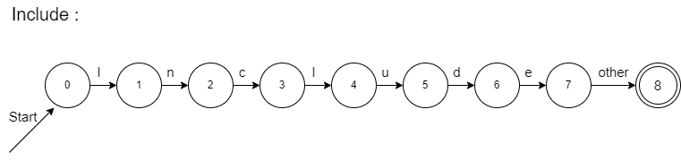

R = Loli
 | NFA STATE | DFA STATE | L | O | L | I | Other | type
{S0} | {S0 , S1} | A | B
{S2} | {S2 , S3} | B |  | C
{S4} | {S4 , S5} | C |  |  | D
{S6} | {S6 , S7} | D |  |  |  | E
{S8} | {S8} | E |  |  |  |  | F
{S9} | {S9} | F |  |  |  |  |  | ACCEPTED

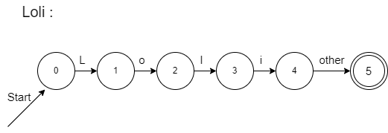

R = Iteratewhen
 | NFA STATE | DFA STATE | I | T | E | R | A | T | E | W | H | E | N | Other | type
{S0} | {S0 , S1} | A | B
{S2} | {S2 , S3} | B |  | C
{S4} | {S4 , S5} | C |  |  | D
{S6} | {S6 , S7} | D |  |  |  | E
{S8} | {S8,S9} | E |  |  |  |  | F
{S10} | {S10,S11} | F |  |  |  |  |  | G
{S12) | {S12,S13) | G |  |  |  |  |  |  | H
{S14} | {S14,S15} | H |  |  |  |  |  |  |  | I
{S16} | {S16,S17} | I |  |  |  |  |  |  |  |  | J
{S18} | {S18,S19} | J |  |  |  |  |  |  |  |  |  | K
{S19} | {S19,S20} | K |  |  |  |  |  |  |  |  |  |  | L
{S21} | {S21} | L |  |  |  |  |  |  |  |  |  |  |  | M
{S22} | {S22} | M |  |  |  |  |  |  |  |  |  |  |  |  | ACCEPTED

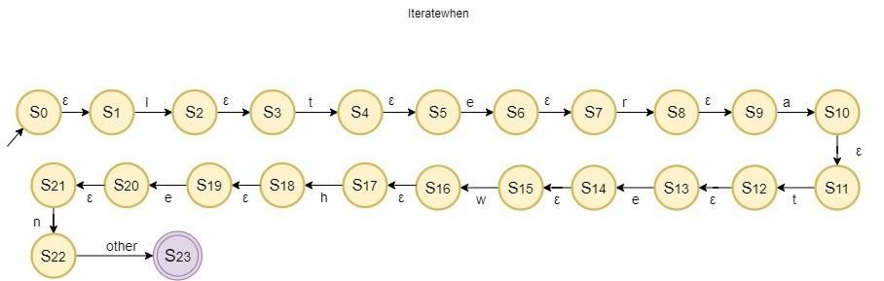
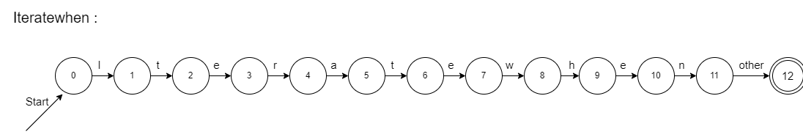

R = Loopwhen

 | NFA STATE | DFA STATE | L | O | O | P | W | H | E | N | OTHER | TYPE
{S0} | {S0 , S1} | A | B
{S2} | {S2 , S3} | B |  | C
{S4} | {S4 , S5} | C |  |  | D
{S6} | {S6 , S7} | D |  |  |  | E
{S8} | {S8,S9} | E |  |  |  |  | F
{S10} | {S10 , S11} | F |  |  |  |  |  | G
{S12) | {S12,S13) | G |  |  |  |  |  |  | H
{S14} | {S14,S15} | H |  |  |  |  |  |  |  | I
{S16} | {S16} | I |  |  |  |  |  |  |  |  | J
{S17} | {S17} | J |  |  |  |  |  |  |  |  |  | ACCEPTED

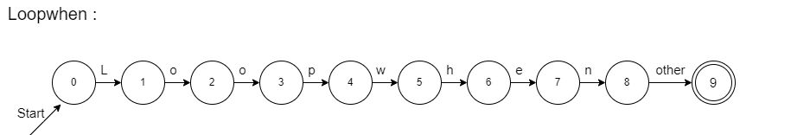

R = Slowf

 | NFA STATE | DFA STATE | S | L | O | W | R | Other | type
{S0} | {S0 , S1} | A | B
{S2} | {S2 , S3} | B |  | C
{S4} | {S4 , S5} | C |  |  | D
{S6} | {S6 , S7} | D |  |  |  | E
{S8} | {S8,S9} | E |  |  |  |  | F
{S10} | {S10 } | F |  |  |  |  |  | G
{S11) | {S11) | G |  |  |  |  |  |  | ACCEPTED

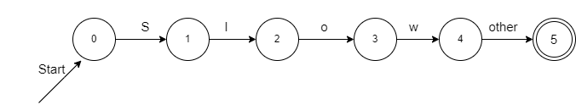

R = Stop

 | NFA STATE | DFA STATE | S | T | O | P | Other | type
{S0} | {S0 , S1} | A | B
{S2} | {S2 , S3} | B |  | C
{S4} | {S4 , S5} | C |  |  | D
{S6} | {S6 , S7} | D |  |  |  | E
{S8} | {S8} | E |  |  |  |  | F
{S9} | {S9} | F |  |  |  |  |  | ACCEPTED

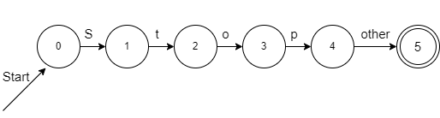

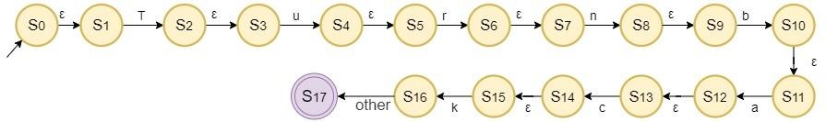
R = Turnback

 | NFA STATE | DFA STATE | T | U | R | N | B | A | C | K | OTHER | type
{S0} | {S0 , S1} | A | B
{S2} | {S2 , S3} | B |  | C
{S4} | {S4 , S5} | C |  |  | D
{S6} | {S6 , S7} | D |  |  |  | E
{S8} | {S8,S9} | E |  |  |  |  | F
{S10} | {S10 , S11} | F |  |  |  |  |  | G
{S12) | {S12,S13) | G |  |  |  |  |  |  | H
{S14} | {S14,S15} | H |  |  |  |  |  |  |  | I
{S16} | {S16} | I |  |  |  |  |  |  |  |  | J
{S17} | {S17} | J |  |  |  |  |  |  |  |  |  | ACCEPTED
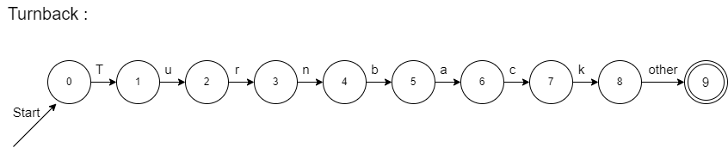

R = Worthless
 | NFA STATE | DFA STATE | W | O | R | T | H | L | E | S | S | OTHER | Type
{S0} | {S0 , S1} | A | B
{S2} | {S2 , S3} | B |  | C
{S4} | {S4 , S5} | C |  |  | D
{S6} | {S6 , S7} | D |  |  |  | E
{S8} | {S8,S9} | E |  |  |  |  | F
{S10} | {S10 , S11} | F |  |  |  |  |  | G
{S12) | {S12,S13) | G |  |  |  |  |  |  | H
{S14} | {S14,S15} | H |  |  |  |  |  |  |  | I
{S16} | {S16,S17} | I |  |  |  |  |  |  |  |  | J
{S18} | {S18} | J |  |  |  |  |  |  |  |  |  | K
{S19} | {S19} | K |  |  |  |  |  |  |  |  |  |  | ACCEPTED

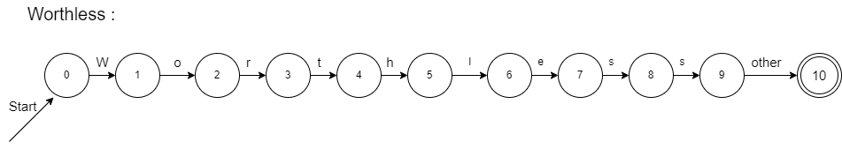

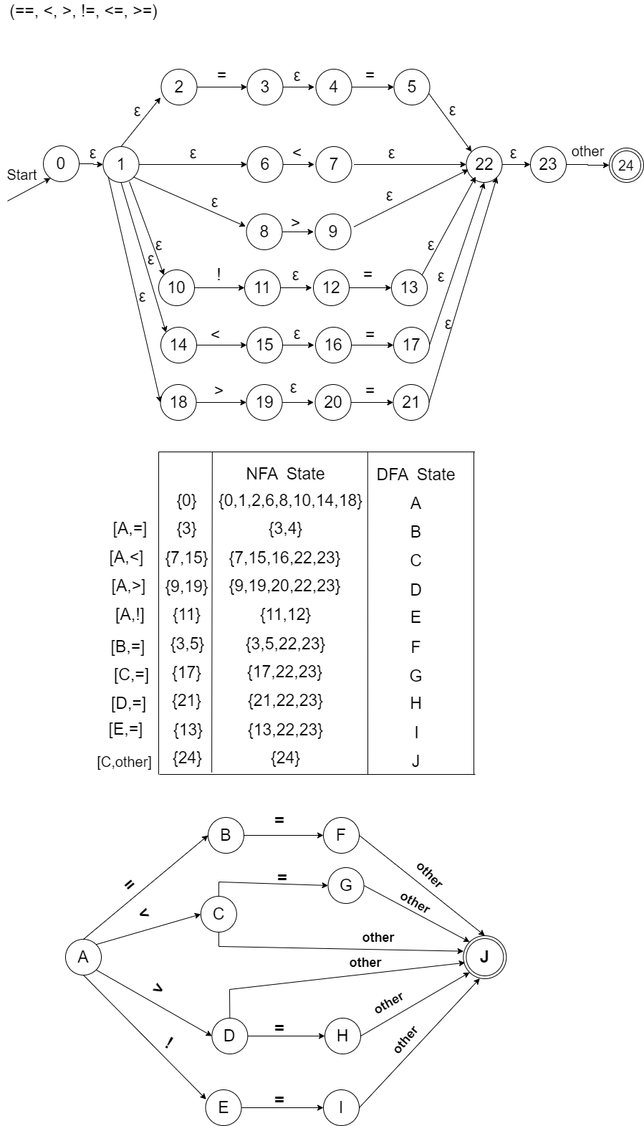
R = (== | <= | != | <= | < | > )

 | NFA State | DFA  State | = | < | > | ! | other | Type
{0} | {0 ,1 ,2,6,8,10,14,18 } | A | B | C | D | E
{3} | {3 , 4} | B | F
{ 7 ,15} | {7, 15 , 16 , 22 , 23 } | C | G |  |  |  | J | Accepted
{ 9 , 19 } | {9, 19 , 20 , 22 , 23 } | D | H |  |  |  | J | Accepted
{11} | { 11 , 12 } | E | I |  |  |  | J | Accepted
{ 3 , 5 } | {3 ,4 , 5 , 22 , 23 } | F |  |  |  |  | J | Accepted
{17} | {17 , 22 , 23 } | G |  |  |  |  | J | Accepted
(21) | {21 , 22 , 23 } | H |  |  |  |  | J | Accepted
{13} | {13 , 22 , 23 } | I |  |  |  |  | J
{24} | { 24 } | J |  |  |  |  |  | Accepted

R = ( + | - | * | / )
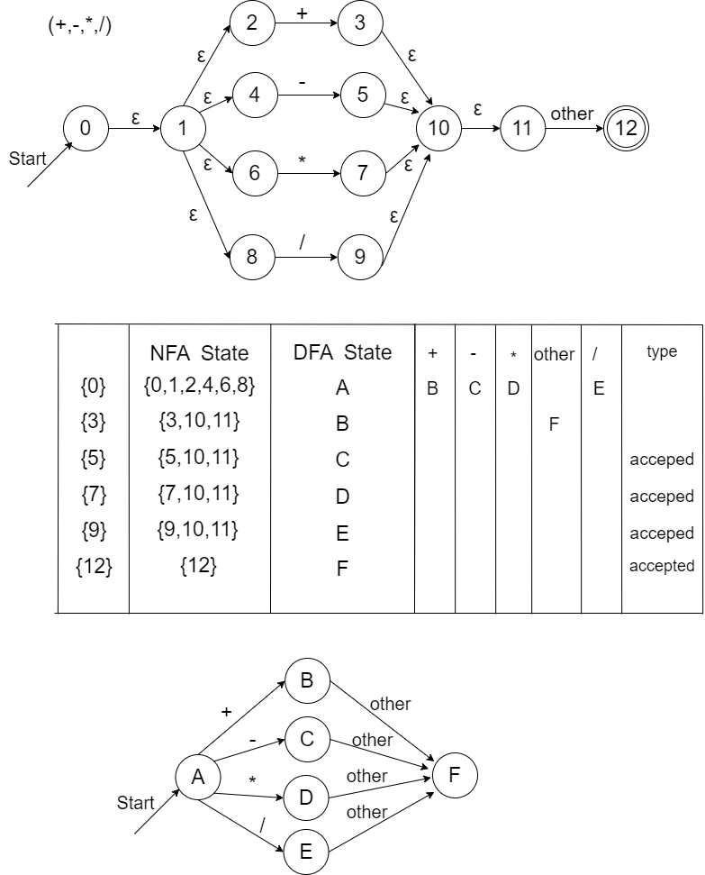

R = Chlo

 | NFA STATE | DFA STATE | c | H | l | o | Other | type
{S0} | {S0 , S1} | A | B
{S2} | {S2 , S3} | B |  | C
{S4} | {S4 , S5} | C |  |  | D
{S6} | {S6 , S7} | D |  |  |  | E
{S8} | {S8} | E |  |  |  |  | F
{S9} | {S9} | F |  |  |  |  |  | ACCEPTED

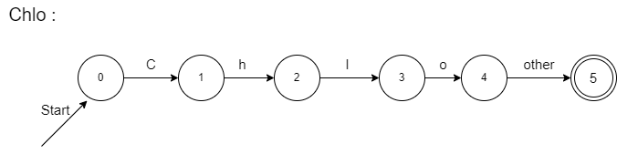
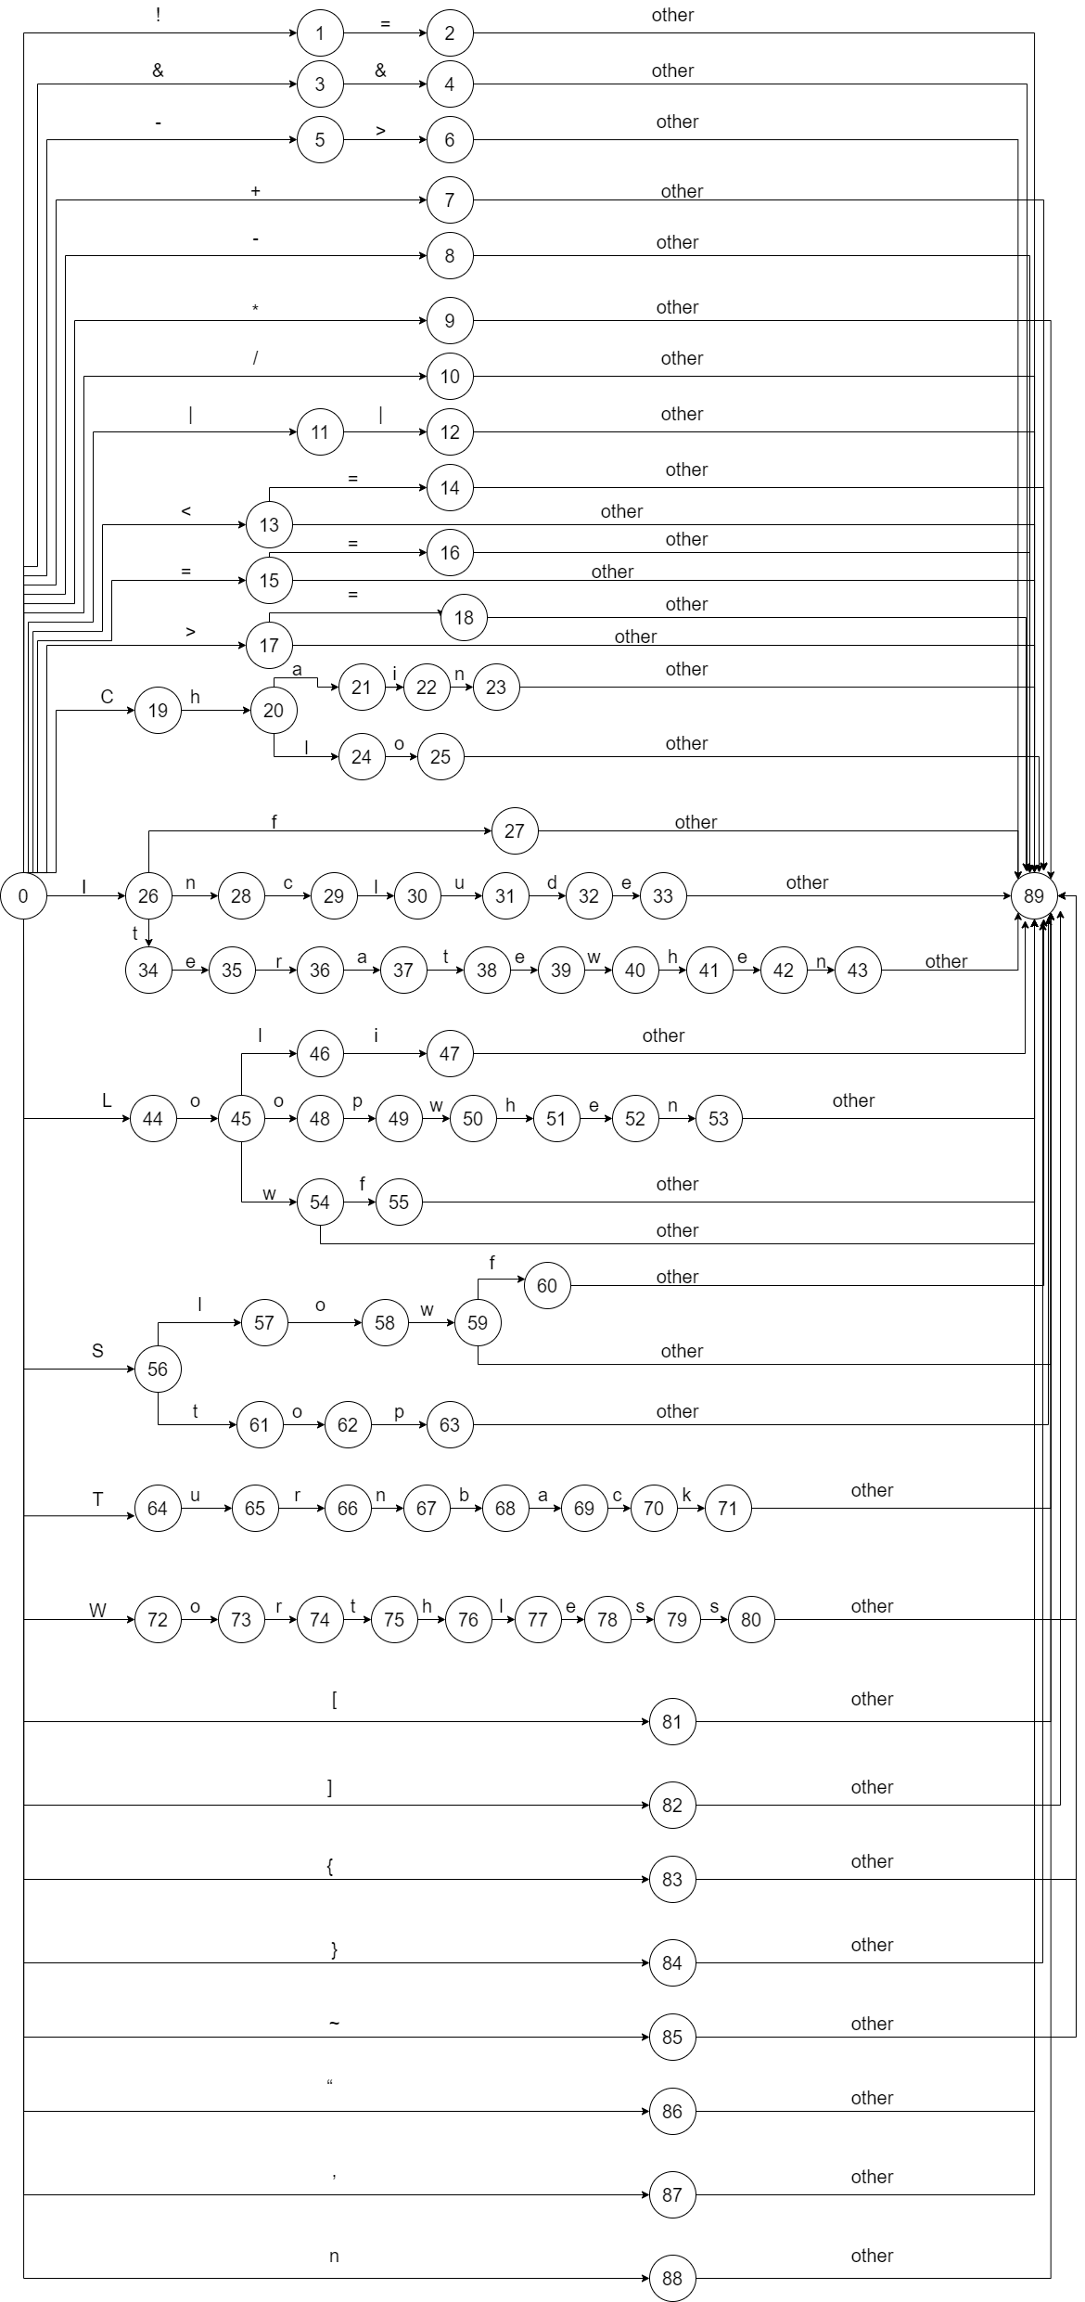
Final DFA :

Parse tree and Abstract syntax tree

